**MAT1011 – Calculus for Engineers (MATLAB), Fall Semester 2020-2021**

**Digital Assignment SL. 7, Experiment – 4A: Double Integrals and Change of Order of Integration**

**By: Jonathan Rufus Samuel (20BCT0332) Date: 17.12.2020**

__________________________________________________________________________________

**Q1) Write a program for the double integral ∬R (x - 3y^2 ) dA where R = {(x,y) | 0<=x<=2 , 1<=y<=2} and visualize it.**

A: Code is as follows:

%Write a program for the double integral ∬R (x-3y^2) dA where

% R = {(x,y)|0<=x<=2, 1<=y<=2} and visualize it

clc

clear all

syms x y z

viewSolid(z, 0+0*x+0*y, x-3*y^2,y,1+0*x, 2+0*x,x,0,2)

int(int(x-3*y^2,y,1,2),x,0,2)

Output (via Command Window):

ans =  
   
-12

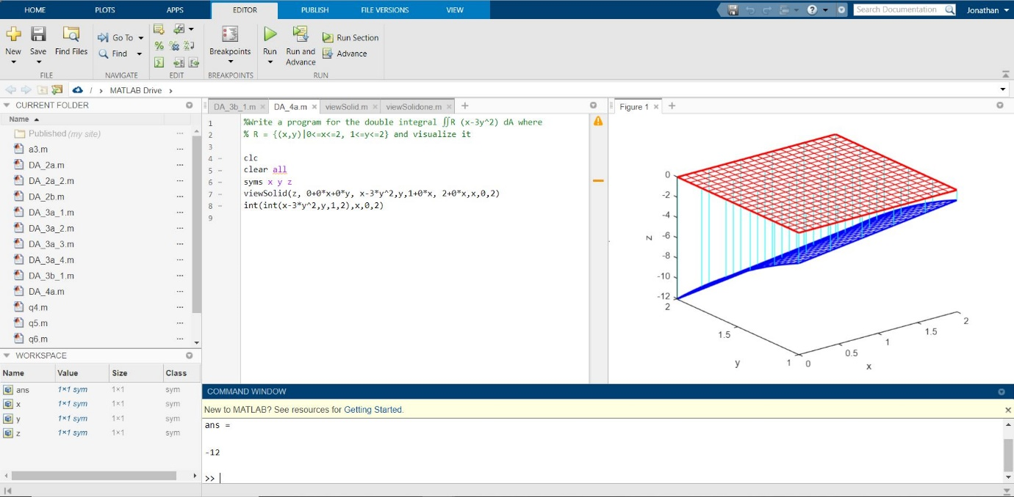

**Additional Files (To be Added to MatLab File Directory):**

**1) viewSolid.m**

function viewSolid(zvar, F, G, yvar, f, g, xvar, a, b)

%VIEWSOLID is a version for MATLAB of the routine on page 161

% of "Multivariable Calculus and Mathematica" for viewing the region

% bounded by two surfaces for the purpose of setting up triple integrals.

% The arguments are entered from the inside out.

% There are two forms of the command --- either f, g,

% F, and G can be vectorized functions, or else they can

% be symbolic expressions. xvar, yvar, and zvar can be

% either symbolic variables or strings.

% The variable xvar (x, for example) is on the

% OUTSIDE of the triple integral, and goes between CONSTANT limits a and b.

% The variable yvar goes in the MIDDLE of the triple integral, and goes

% between limits which must be expressions in one variable [xvar].

% The variable zvar goes in the INSIDE of the triple integral, and goes

% between limits which must be expressions in two

% variables [xvar and yvar]. The lower surface is plotted in red, the

% upper one in blue, and the "hatching" in cyan.

%

% Examples: viewSolid(z, 0, (x+y)/4, y, x/2, x, x, 1, 2)

% gives the picture on page 163 of "Multivariable Calculus and Mathematica"

% and the picture on page 164 of "Multivariable Calculus and Mathematica"

% can be produced by

% viewSolid(z, x^2+3*y^2, 4-y^2, y, -sqrt(4-x^2)/2, sqrt(4-x^2)/2, ...

% x, -2, 2,)

% One can also type viewSolid('z', @(x,y) 0, ...

% @(x,y)(x+y)/4, 'y', @(x) x/2, @(x) x, 'x', 1, 2)

%

if isa(f, 'sym') % case of symbolic input

ffun=inline(vectorize(f+0*xvar),char(xvar));

gfun=inline(vectorize(g+0*xvar),char(xvar));

Ffun=inline(vectorize(F+0*xvar),char(xvar),char(yvar));

Gfun=inline(vectorize(G+0*xvar),char(xvar),char(yvar));

oldviewSolid(char(xvar), double(a), double(b), ...

char(yvar), ffun, gfun, char(zvar), Ffun, Gfun)

else

oldviewSolid(char(xvar), double(a), double(b), ...

char(yvar), f, g, char(zvar), F, G)

end

%%%%%%% subfunction goes here %%%%%%

function oldviewSolid(xvar, a, b, yvar, f, g, zvar, F, G)

for counter=0:20

xx = a + (counter/20)*(b-a);

YY = f(xx)*ones(1, 21)+((g(xx)-f(xx))/20)*(0:20);

XX = xx*ones(1, 21);

**%% The next lines inserted to make bounding curves thicker.**

widthpar=0.5;

if counter==0, widthpar=2; end

if counter==20, widthpar=2; end

**%% Plot curves of constant x on surface patches.**

plot3(XX, YY, F(XX, YY).*ones(1,21), 'r', 'LineWidth', widthpar);

hold on

plot3(XX, YY, G(XX, YY).*ones(1,21), 'b', 'LineWidth', widthpar);

end;

**%% Now do the same thing in the other direction.**

XX = a*ones(1, 21)+((b-a)/20)*(0:20);

**%% Normalize sizes of vectors.**

YY=0:2; ZZ1=0:20; ZZ2=0:20;

for counter=0:20,

**%% The next lines inserted to make bounding curves thicker.**

widthpar=0.5;

if counter==0, widthpar=2; end

if counter==20, widthpar=2; end

for i=1:21,

YY(i)=f(XX(i))+(counter/20)*(g(XX(i))-f(XX(i)));

ZZ1(i)=F(XX(i),YY(i));

ZZ2(i)=G(XX(i),YY(i));

end;

plot3(XX, YY, ZZ1, 'r', 'LineWidth',widthpar);

plot3(XX, YY, ZZ2, 'b', 'LineWidth',widthpar);

end;

**%% Now plot vertical lines.**

for u = 0:0.2:1,

for v = 0:0.2:1,

x=a + (b-a)*u; y = f(a + (b-a)*u) +(g(a + (b-a)*u)-f(a + (b-a)*u))*v;

plot3([x, x], [y, y], [F(x,y), G(x, y)], 'c');

end;

end;

xlabel(xvar)

ylabel(yvar)

zlabel(zvar)

hold off

**2) viewSolidone.m**

function viewSolidone(zvar, F, G, xvar, f, g, yvar, a, b)

%VIEWSOLID is a version for MATLAB of the routine on page 161

% of "Multivariable Calculus and Mathematica" for viewing the region

% bounded by two surfaces for the purpose of setting up triple integrals.

% The arguments are entered from the inside out.

% There are two forms of the command --- either f, g,

% F, and G can be vectorized functions, or else they can

% be symbolic expressions. xvar, yvar, and zvar can be

% either symbolic variables or strings.

% The variable xvar (x, for example) is on the

% OUTSIDE of the triple integral, and goes between CONSTANT limits a and b.

% The variable yvar goes in the MIDDLE of the triple integral, and goes

% between limits which must be expressions in one variable [xvar].

% The variable zvar goes in the INSIDE of the triple integral, and goes

% between limits which must be expressions in two

% variables [xvar and yvar]. The lower surface is plotted in red, the

% upper one in blue, and the "hatching" in cyan.

%

% Examples: viewSolid(z, 0, (x+y)/4, y, x/2, x, x, 1, 2)

% gives the picture on page 163 of "Multivariable Calculus and Mathematica"

% and the picture on page 164 of "Multivariable Calculus and Mathematica"

% can be produced by

% viewSolid(z, x^2+3*y^2, 4-y^2, y, -sqrt(4-x^2)/2, sqrt(4-x^2)/2, ...

% x, -2, 2,)

% One can also type viewSolid('z', @(x,y) 0, ...

% @(x,y)(x+y)/4, 'y', @(x) x/2, @(x) x, 'x', 1, 2)

%

if isa(f, 'sym') % case of symbolic input

ffun=inline(vectorize(f+0*yvar),char(yvar));

gfun=inline(vectorize(g+0*yvar),char(yvar));

Ffun=inline(vectorize(F+0*xvar),char(xvar),char(yvar));

Gfun=inline(vectorize(G+0*xvar),char(xvar),char(yvar));

oldviewSolid(char(yvar),double(a), double(b), ...

char(xvar), ffun, gfun, char(zvar), Ffun, Gfun)

else

oldviewSolid(char(yvar),double(a),double(b),char(xvar), f, g, char(zvar), F, G)

end

%%%%%%% subfunction goes here %%%%%%

function oldviewSolid(yvar,a , b, xvar, f, g, zvar, F, G)

for counter=0:30

yy= a + (counter/30)*(b-a);

XX = f(yy)*ones(1, 31)+((g(yy)-f(yy))/30)*(0:30);

YY = yy*ones(1, 31);

%% The next lines inserted to make bounding curves thicker.

widthpar=0.5;

if counter==0, widthpar=2; end

if counter==20, widthpar=2; end

%% Plot curves of constant x on surface patches.

plot3(YY,XX, F(XX, YY).*ones(1,31), 'r', 'LineWidth', widthpar);

hold on

plot3(YY,XX, G(XX, YY).*ones(1,31), 'b', 'LineWidth', widthpar);

end;

%% Now do the same thing in the other direction.

YY = a*ones(1, 31)+((b-a)/30)*(0:30);

%% Normalize sizes of vectors.

XX=0:2; ZZ1=0:30; ZZ2=0:30;

for counter=0:30,

%% The next lines inserted to make bounding curves thicker.

widthpar=0.5;

if counter==0, widthpar=2; end

if counter==30, widthpar=2; end

for i=1:31,

XX(i)=f(YY(i))+(counter/30)*(g(YY(i))-f(YY(i)));

ZZ1(i)=F(YY(i),XX(i));

ZZ2(i)=G(YY(i),XX(i));

end;

plot3(YY,XX, ZZ1, 'r', 'LineWidth',widthpar);

plot3(YY,XX, ZZ2, 'g', 'LineWidth',widthpar);

end;

%% Now plot vertical lines.

for u = 0:0.09:1,

for v = 0:0.09:1,

y=a + (b-a)*u; x = f(a + (b-a)*u) +(g(a + (b-a)*u)-f(a + (b-a)*u))*v;

plot3([y, y], [x, x], [F(x,y), G(x, y)], 'c');

end;

end;

xlabel(xvar)

ylabel(yvar)

zlabel(zvar)

hold off

__________________________________________________________________________________